1. What is scope?

Scope refers to the space in a code snippet where a variable exists and can be referenced

2. What are the 3 different levels of scope?

1. Class / Instance level scope (global variables)

2. Method level scope (variables declared inside a method/function)

3. Block level scope (variables declared in a for-loop, if-statement, etc.)

3. What is wrong with the following code snippet?

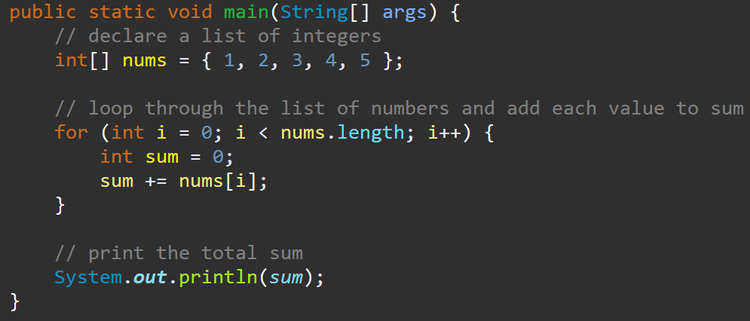

The variable sum is declared inside a for-loop, which means it can only be accessed inside the for-loop.

4. Given the following code, identify the scope of each variable:

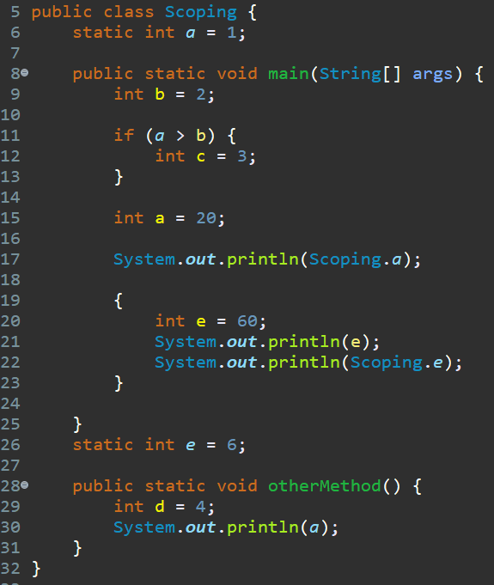

a (line 6): Class level__

b: Method level__________

c: Block level___________

a (line 15): Method level

d: Method level__________

e: Class level___________

5. Given the following code snippet, which line represents the ***best place*** the variable nextNum should be declared?

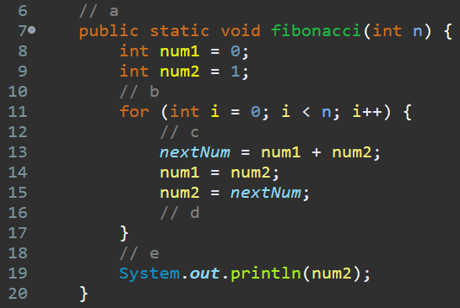

a. line 6

b. line 10

**c. line 12**

d. line 16

e. line 18